Smiles & Sunshine Toy System - System Documentation

A. Driving Question
How can good human-computer interaction design help improve user satisfaction with the Smiles & Sunshine Toy System, and what advantages does it bring in this regard?
Good HCI design is a core factor in the success of the Smiles & Sunshine Toy System, directly enhancing user satisfaction and delivering significant advantages in multiple ways. First, the system adopts an intuitive interface design, significantly lowering the learning curve for users. Whether customers or sales staff, they can quickly grasp the operational workflow, directly reducing user frustration and abandonment rates.
Second, the system helps users complete tasks efficiently through clear visual hierarchy and logical content organization. Step-by-step toy customization processes, transparent order status tracking, and instant feedback mechanisms all enhance users’ sense of control and trust. Especially during complex customization processes, the system breaks down selection items into manageable steps, avoiding information overload.
Third, responsive design ensures a consistent experience across devices. Whether users access the system on desktop computers, tablets, or mobile phones, they receive optimized interface layouts and interaction methods, meeting the needs of modern users in multi-scenario, multi-device usage.
These design advantages translate into concrete business benefits: increased user conversion rates, reduced demand for customer support, enhanced user loyalty, and the establishment of a differentiated edge in the highly competitive e-commerce market. Ultimately, good HCI design not only achieves functional goals but also creates positive experiences on an emotional level, making Smiles & Sunshine Toys the brand of choice for users.

B. User Analysis
User Characteristics
Customer Group Analysis:
- Primary Age Range: Parents and relatives/friends aged 25–45
- Gender Distribution: 65% female, 35% male (primary purchase decision-makers)
- Education Level: 80% hold college diplomas or higher
- Technical Proficiency: Medium to high, familiar with basic online shopping operations
- Purchase Motivation: Holiday gifts (45%), daily rewards (30%), special occasions (25%)
- Key Concerns: Product quality (90%), delivery time (85%), clarity of customization options (75%)
Sales Staff Group Analysis:
- Age Range: Retail employees aged 22–50
- Work Experience: Average 2–5 years in toy retail
- Technical Skills: Basic to medium, require simplified workflows
- Primary Responsibilities: Order processing (40%), customer communication (30%), inventory management (20%), report generation (10%)
- Pain Points & Needs: Support for multitasking, quick information retrieval, reduction of repetitive operations

Techniques for Observing and Listening to Users

1.Contextual Inquiry & Observation
- Method: Semi-structured interviews combined with real-world observation
- Participants: 8 families with children (2 hours per group)
- Process: Observed toy purchase decision-making processes in users' homes
- Finding: Parents tend to browse toy websites between 9 PM–11 PM; decisions are significantly influenced by social media recommendations

2.Usability Testing
Early Stage: Paper prototype testing (5 users)
- Mid Stage: Interactive prototype testing (10 users)
- Late Stage: Fully functional system testing (15 users)
- Key Metrics: Task completion rate, error rate, time efficiency, satisfaction score

3.Questionnaire Survey
- Sample Size: 152 valid questionnaires collected
- Survey Focus: Customization preferences, price acceptance, delivery expectations, interface preferences
- Key Finding: 70% of users are willing to pay a 20–30% premium for customized toys; delivery time accuracy is their top concern.

4.Log Analysis & Competitive Research
  - Analyzed user reviews from 3 main competitors (500+ reviews total)
  - Identified common pain points: Confusing customization options, untimely status updates, poor mobile experience
  - Identified opportunities: Clear customization process, real-time status tracking, cross-device consistency

Environment Analysis
Physical Environment Analysis:
- Customer Usage Scenarios:
  - Home environment (Living room 68%, Bedroom 22%)
  - Mobile environment (During commute 8%, Waiting time 2%)
  - Characteristics: Prone to interruptions, fragmented time, multitasking
- Sales Staff Work Environment:
  - Retail store (70%): Noisy, multitasking, standing work
  - Office (30%): Relatively quiet, prolonged seated work

Technical Environment Analysis:
- Device Usage Distribution: Desktop computers (55%), Smartphones (38%), Tablets (7%)
- Browser Distribution: Chrome (65%), Safari (20%), Firefox (10%), Others (5%)
- Network Conditions: Most users use Wi-Fi (85%), Mobile networks (15%)
- Resolution Distribution: 1920×1080 (40%), 1366×768 (25%), Mobile resolutions (35%)

Socio-Cultural Environment:
- Purchase decisions often involve multiple people (both parents 78%, grandparents involved 15%)
- Social influence is significant: Friend recommendations (45%), Influencer recommendations (30%), Online reviews (25%)
- Cultural Factors: Holiday gifting traditions, emphasis on educational value, safety concerns

Organizational Environment (Sales Staff):
- Workflow: Order receipt → Confirmation → Processing → Shipping → Tracking
- Communication Needs: Coordination with customers, warehouse, and logistics
- Time Pressure: Order volume increases by 300% during holiday seasons, requiring efficient processing systems

Recruiting Users
Recruitment Strategy & Execution:
- Multi-Channel Recruitment:
  - Social media parenting groups (recruited 35 parent users)
  - Collaboration with local kindergartens (recruited 15 families)
  - On-site recruitment at toy fairs (recruited 22 potential users)
  - Email invitations to existing customers (recruited 28 loyal users)
- Stratified Sampling for Representativeness:
  - Age Groups: 25–35 years old (45%), 36–45 years old (40%), 46+ years old (15%)
  - Technical Skill Level: Beginner (20%), Intermediate (60%), Advanced (20%)
  - User Type: First-time buyers (30%), Repeat buyers (70%)

- Incentive Mechanism:
  - Testing participation gift: HK$50 toy discount voucher
  - Reward for completing all testing phases: HK$100 shopping voucher
  - Special contribution reward: Free customized toy (worth HK$300)
- Testing Schedule:
  - Stage 1 (Exploratory Testing): 5 users, 60 minutes per session
  - Stage 2 (Prototype Testing): 10 users, 45 minutes per session
  - Stage 3 (System Testing): 15 users, 30 minutes per session
  - Total: 30 hours of testing time, covering all key functions.

Task Analysis (HTA)
Main Goal Hierarchy:
0. Purchase a customized toy in the Smiles & Sunshine System
1. Access the system and create an account
1.1 Access the website homepage
1.2 Register a new account
1.2.1 Select user type (Customer/Sales Staff)
1.2.2 Fill in basic information (name, email, phone)
1.2.3 Set password and agree to terms
1.3 Log in to the system
1.3.1 Enter registered email
1.3.2 Enter password
1.3.3 Select user type
1.3.4 Click login button
2. Browse and select a toy
2.1 Browse the toy catalog
2.1.1 View recommended toys
2.1.2 Browse category lists
2.2 Search for a specific toy
2.2.1 Enter keywords in the search box
2.2.2 Apply filters (price, age, category)
2.2.3 View search results
2.3 View toy details
2.3.1 Click a toy card to view details
2.3.2 Read the full description and specifications
2.3.3 View sample images
3. Customize toy options
3.1 Select base model
3.2 Select appearance options
3.2.1 Select main body color
3.2.2 Select accessory color
3.3 Add personalized elements
3.3.1 Add personalized text (max 20 characters)
3.3.2 Select text font and color
3.4 Select packaging options
3.4.1 Select packaging type (standard/gift)
3.4.2 Add greeting card (optional)
4. Manage purchase decision
4.1 Select purchase quantity
4.2 Add to wishlist (temporary save)
4.2.1 Set priority marker
4.2.2 Add notes/comments
4.3 Or add directly to shopping cart
5. Complete purchase process
5.1 Go to shopping cart
5.2 Confirm order contents
5.2.1 Verify toy specifications and customization options
5.2.2 Confirm quantity
5.3 Select delivery options
5.3.1 Select delivery address
5.3.2 Select delivery method (standard/express)
5.3.3 Select delivery time window
5.4 Select payment method
5.4.1 Credit/Debit Card
5.4.2 PayPal
5.4.3 Bank Transfer
5.5 Confirm and submit order
6. Track and manage order
6.1 View order status
6.1.1 View current status (Pending/Confirmed/Shipped/Delivered)
6.1.2 View estimated delivery date
6.2 Receive status updates
6.2.1 Email notifications
6.2.2 In-system notifications
6.3 Manage past orders
6.3.1 View past orders
6.3.2 Reorder favorite toys

Sales Staff Task Analysis:
0. Manage and process customer orders
1. Log in to the Sales Staff Dashboard
2. Monitor new orders
2.1 View new order notifications
2.2 Filter priority orders
3. Process a single order
3.1 Review order details
3.1.1 Confirm customization requirements
3.1.2 Check inventory availability
3.2 Update order status
3.2.1 Confirm the order
3.2.2 Set estimated delivery date
3.3 Coordinate with production department
4. Customer communication & support
4.1 Answer customer inquiries
4.2 Send order confirmation
4.3 Notify about order status updates
5. Order tracking & completion
5.1 Update logistics information
5.2 Confirm order delivery
5.3 Handle customer feedback

C. Web Design Concepts
C.1 Overview of Design Principles
In the design and development process of the Smile & Sunshine Toy System, we systematically applied five core web design principles: mental models, affordances, content organization, visual organization, and navigation design. These principles not only guided the visual design of the interface but also ensured the system's functionality, usability, and user experience. By combining theoretical principles with practical application, we created an e-commerce platform that is both aesthetically pleasing and efficient, meeting the dual needs of customers and sales personnel.

C.2 Application of Mental Models
Mental models refer to the internal cognitive frameworks that users form based on past experiences regarding how a system works. The interface design of this system strictly adheres to users' existing mental models of e-commerce platforms, ensuring that new users can quickly understand system functions based on their prior experience.
C.2.1 Homepage Design
The system homepage (Figure 1) adopts a standard commercial website structure: the top navigation bar contains the brand logo and main functional entry points, the central hero area showcases the core value proposition and main call-to-action, and the bottom provides an introduction to service features. This layout is highly consistent with mainstream e-commerce platforms such as Amazon and Taobao, enabling new users to immediately identify the website type and basic operation methods.
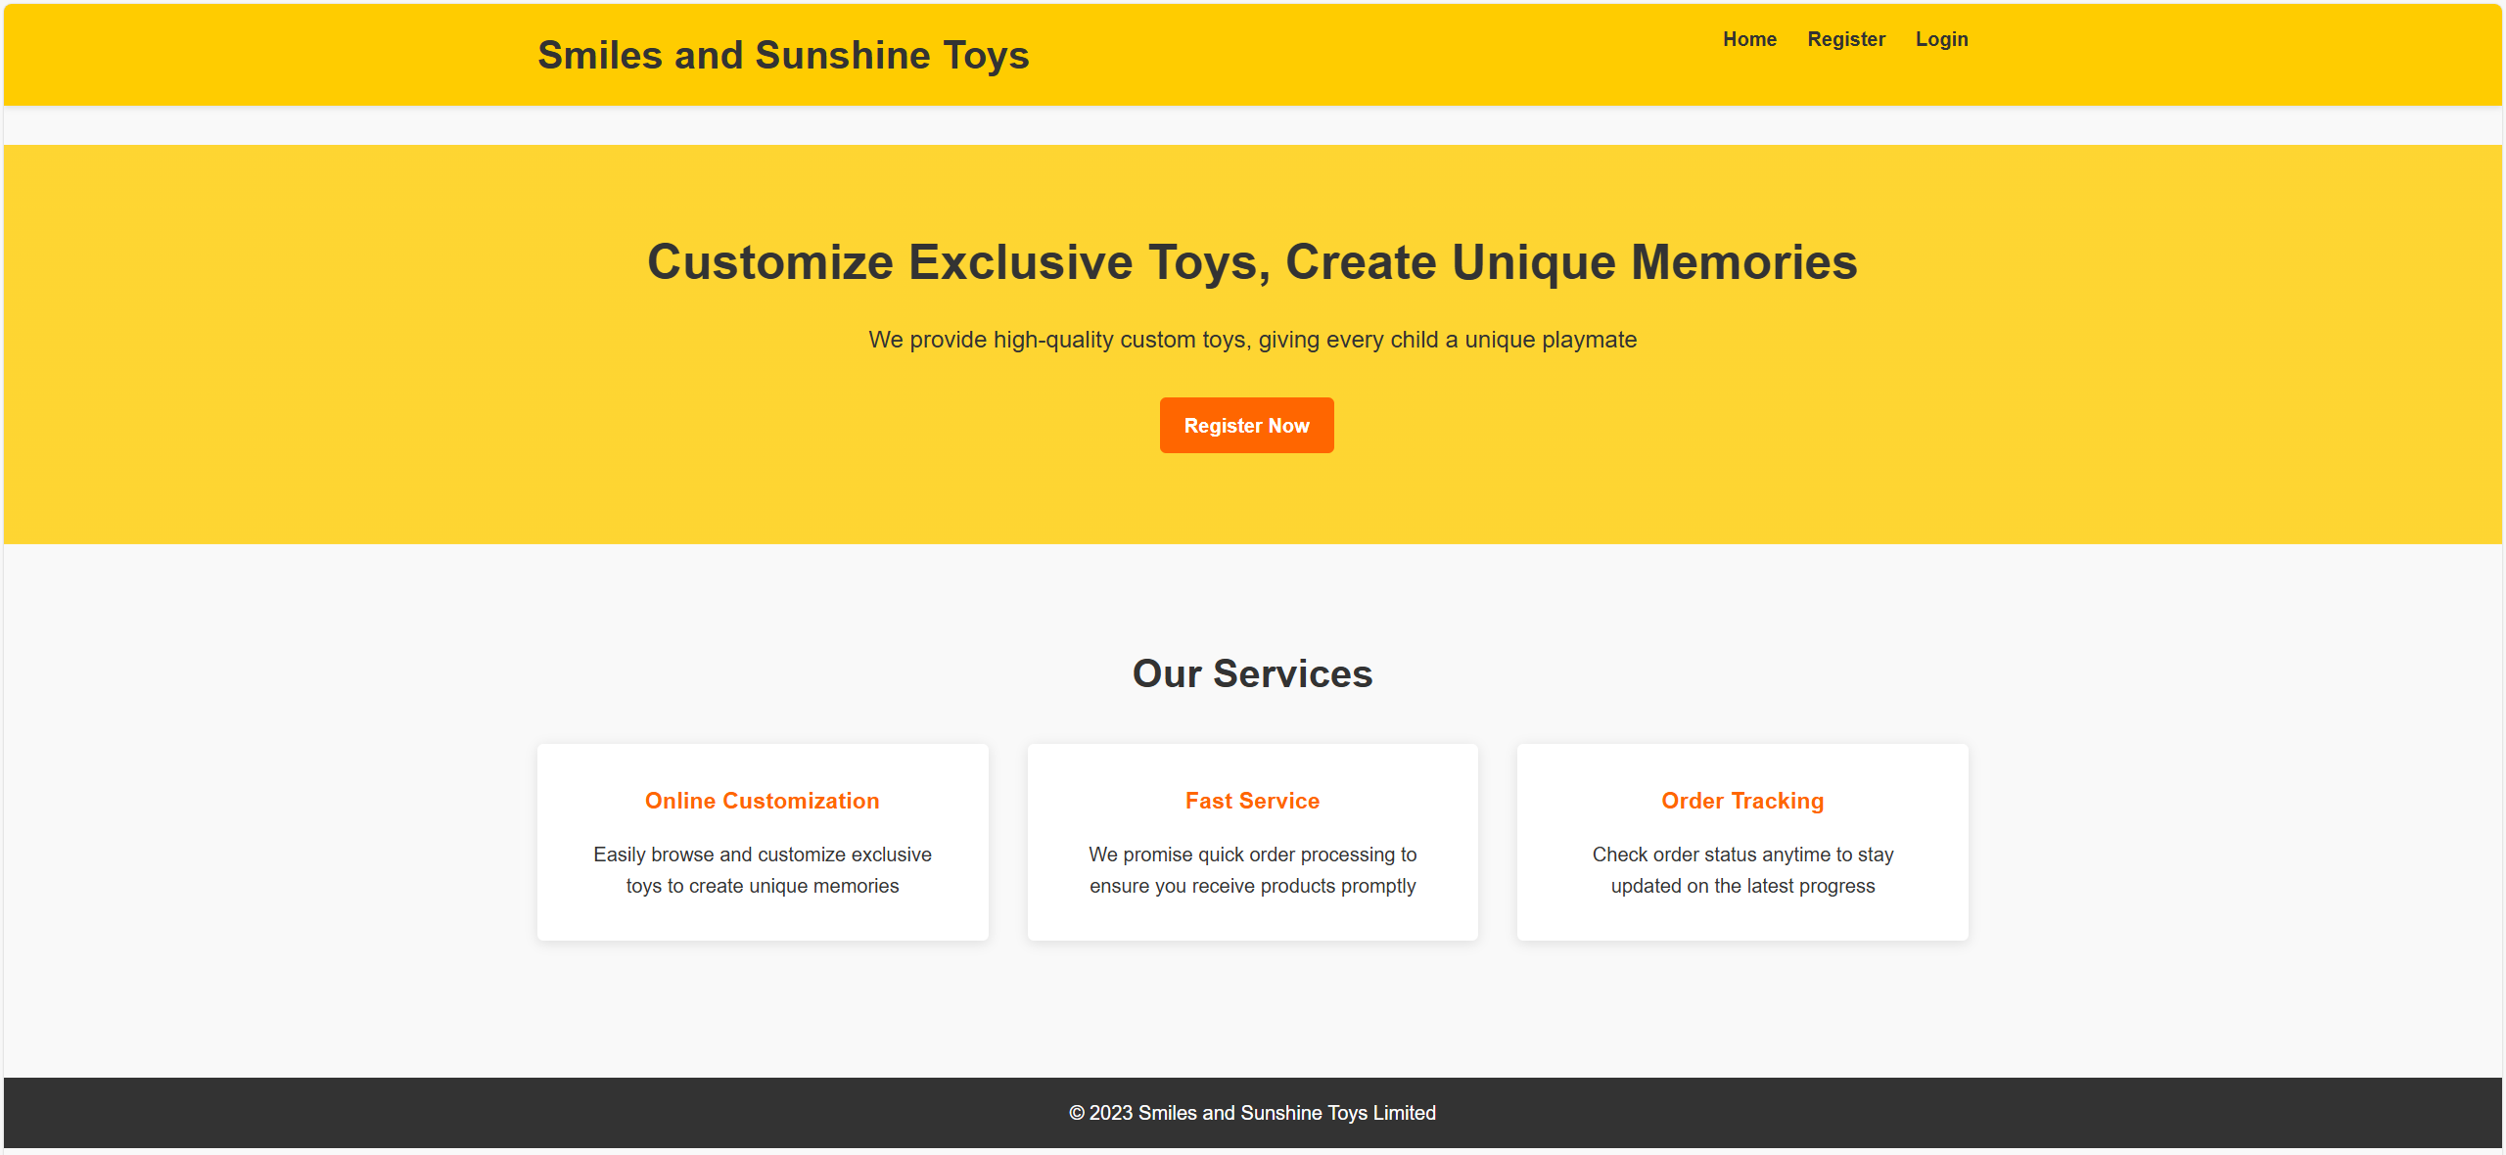
*Figure 1: System homepage interface, showcasing the standard e-commerce website layout structure*

C.2.2 Registration Interface
The registration page (Figure 2) uses tabbed navigation to distinguish between customer and salesperson registration processes. Form fields adopt the industry-standard vertical layout (labels above, input boxes below). This design reduces users' cognitive load because they do not need to learn new form interaction patterns to complete the registration process.
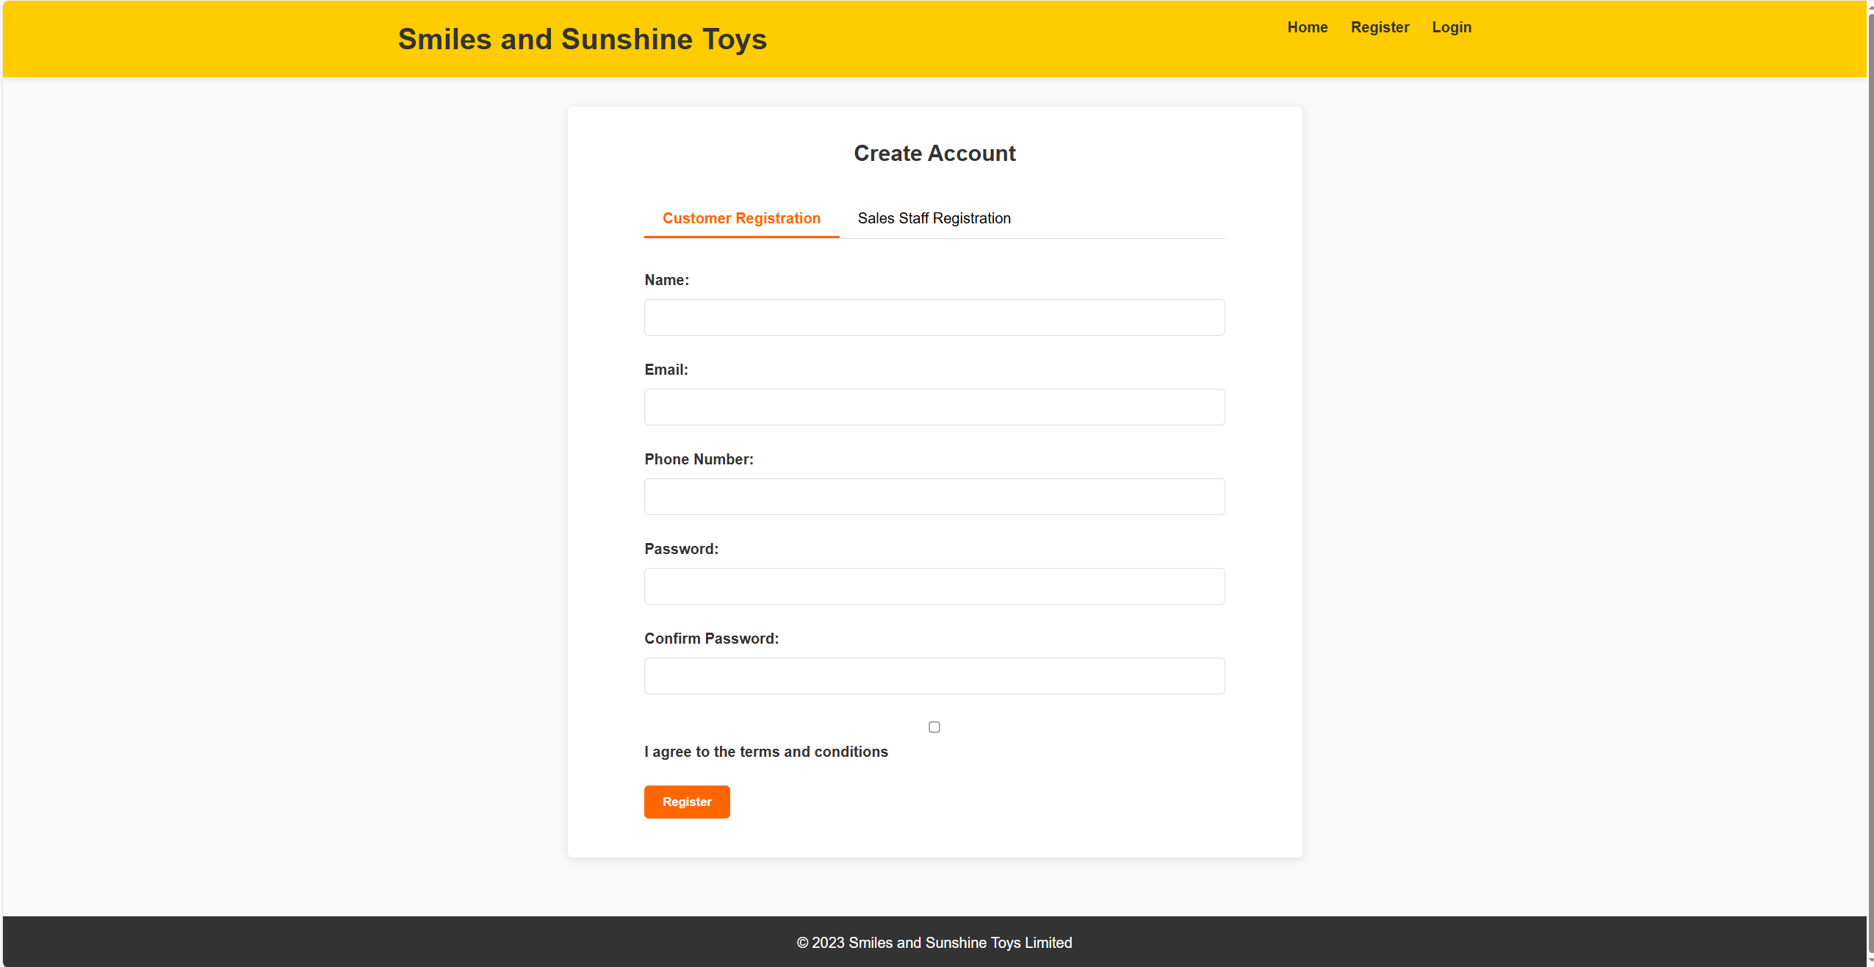
*Figure 2: Registration page, employing user-familiar tabbed navigation and form design*

C.2.3 Login Function
The login function (Figure 3) is implemented as a modal dialog box, which is a common pattern for handling login operations on modern websites. The dialog box includes a clear closing mechanism, a clear form structure, and standard submit buttons, fully meeting user expectations for pop-up login interfaces.
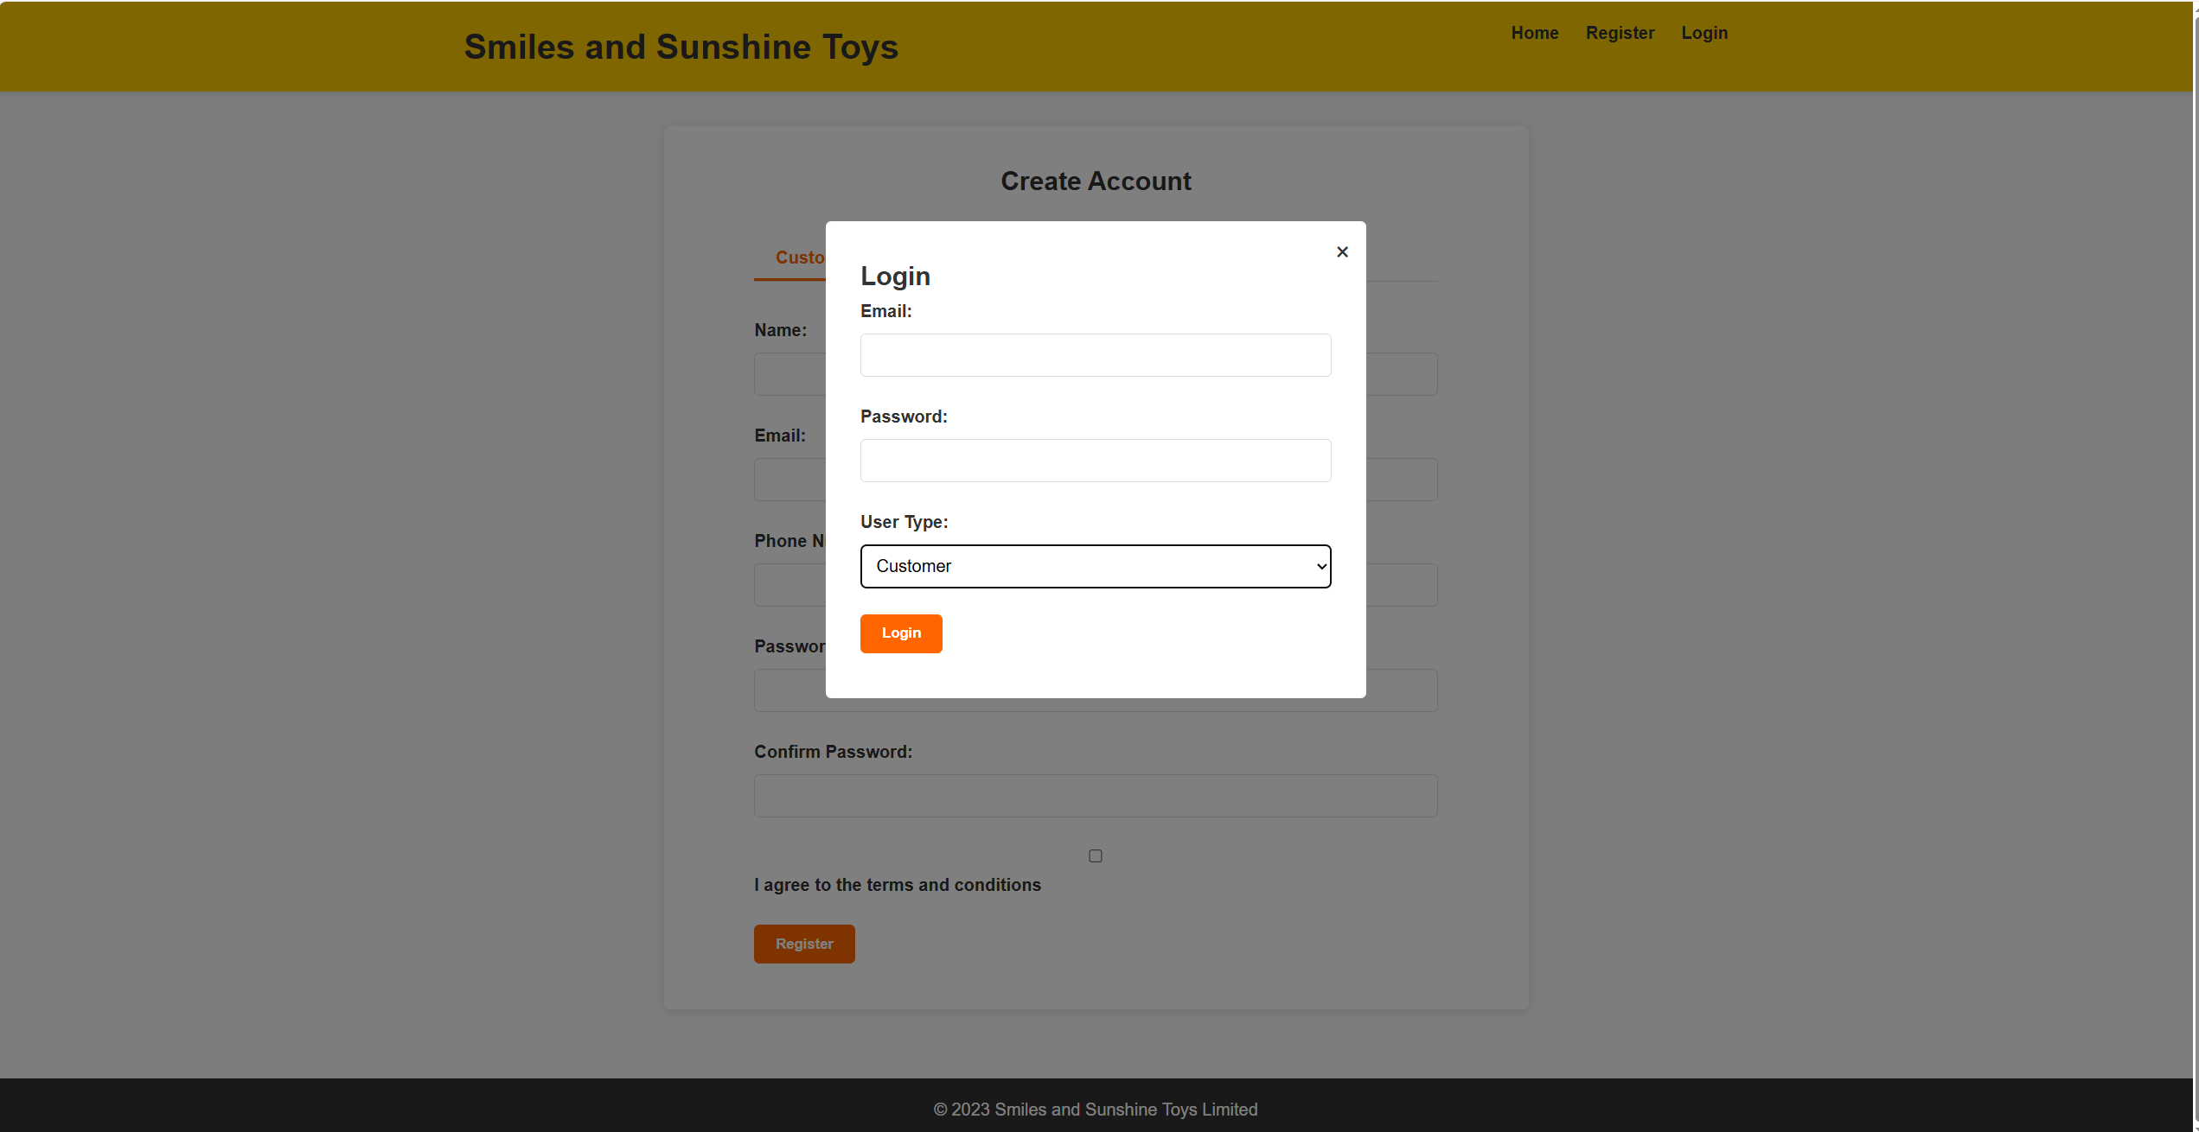
*Figure 3: Login modal, conforming to design conventions for pop-up login interfaces*

C.3 Implementation of Affordances
Affordances refer to the ability of interface elements to clearly convey their functions and methods of operation through visual design. This system ensures that users can intuitively understand the purpose of each interface element through consistent visual language and interactive feedback.

C.3.1 Interactive Element Design
Buttons and clickable elements in the system (Figure 4) clearly convey their interactivity through color, shape, and hover effects. Primary action buttons use high-contrast orange backgrounds, while secondary buttons use gray, with a clear distinction in visual weight. All buttons have rounded corners and shadows, and produce color darkening or shadow changes upon hovering, providing clear interactive feedback.
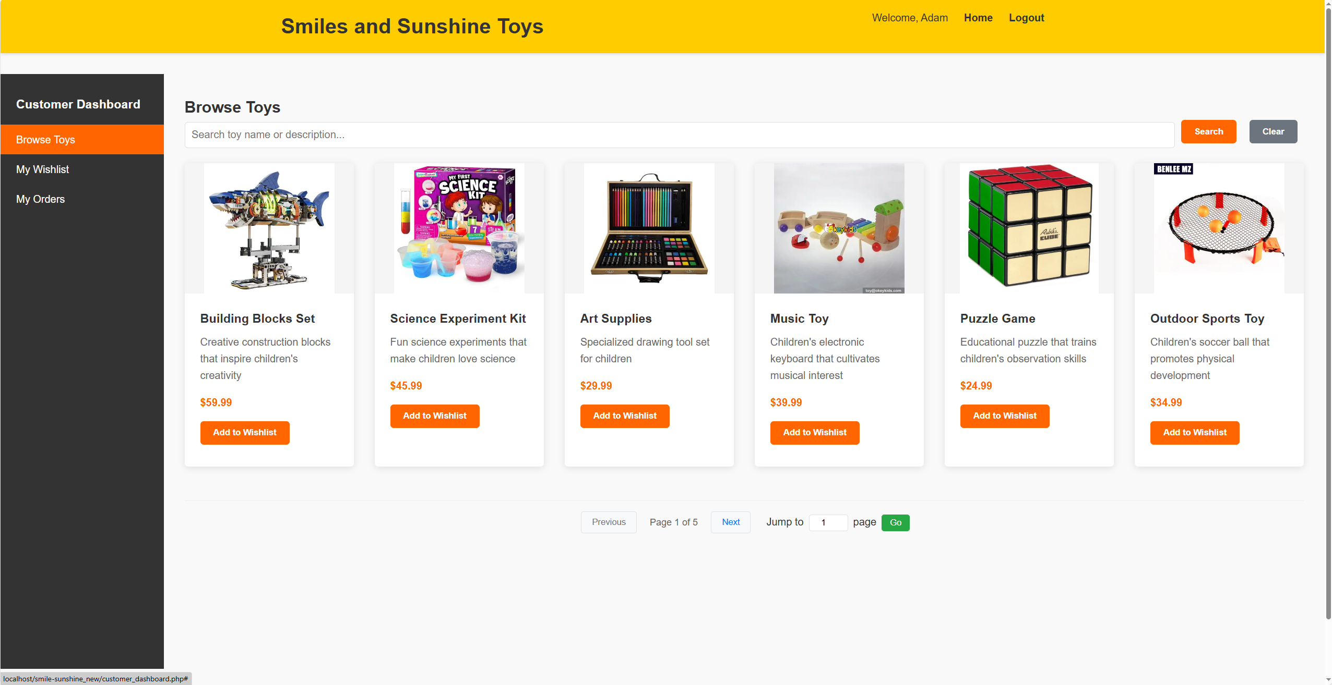
Figure 4: Interactive element design on the toy browsing page, showcasing the visual affordances of buttons

C.3.2 Form Field Design
Form fields (Figure 5) convey their interaction methods through multiple visual cues: text input boxes have distinct borders and padding, dropdown menus display arrows on the right, and number input boxes include increment/decrement buttons. These design elements collectively ensure that users can accurately predict how to operate each form field.
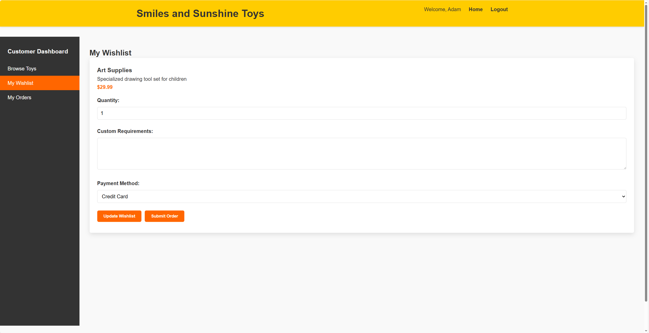
Figure 5: Form fields for wishlist items, showcasing different types of input controls

C.3.3 Navigation State Feedback
Navigation elements (Figure 6) clearly convey their interactive states through visual state changes. Currently active navigation items use highlighted background colors, inactive items change color upon hovering, and disabled buttons use gray and reduced opacity. This visual feedback helps users understand the current state of the system and available actions.
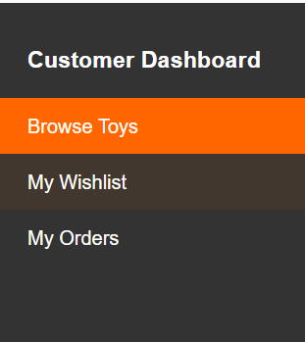
Figure 6: State feedback design of the sidebar navigation

C.4 Content Organization Strategy
Content organization refers to the method of grouping and sequencing information according to logical relationships and user task flows. This system adopts a hierarchical information architecture, breaking down complex functions into manageable task units.

C.4.1 Information Architecture Design
The toy browsing page (Figure 7) adopts a three-layer information architecture: the top layer contains search and filtering tools, the middle layer is the product display area, and the bottom layer contains navigation controls. This structure logically groups discovery tools, content display, and navigation functions, supporting users in efficiently discovering and browsing products.
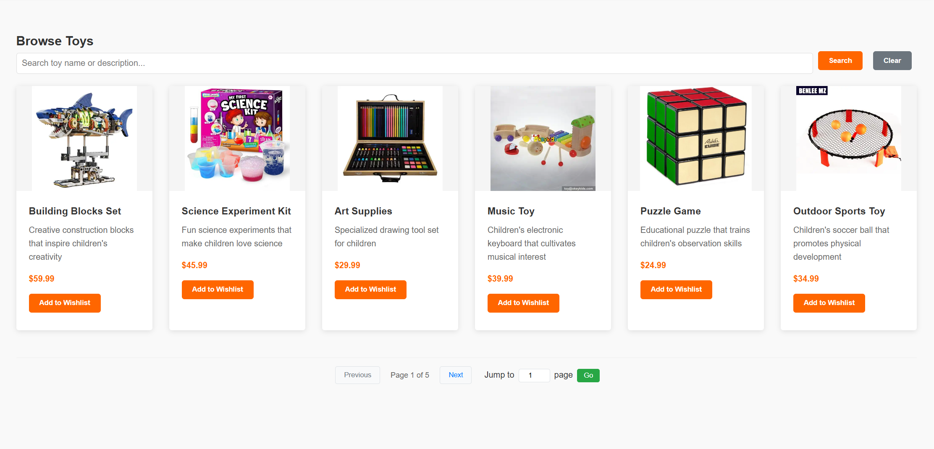
Figure 7: Information architecture design of the toy browsing interface

C.4.2 Functional Grouping Logic
The wishlist interface (Figure 8) groups related functions within the same visual unit. Each toy item contains three functional groups: basic information area (name, description, price), customization options area (quantity, personalization requirements), and action area (update, submit). This grouping follows the natural flow of users completing tasks.
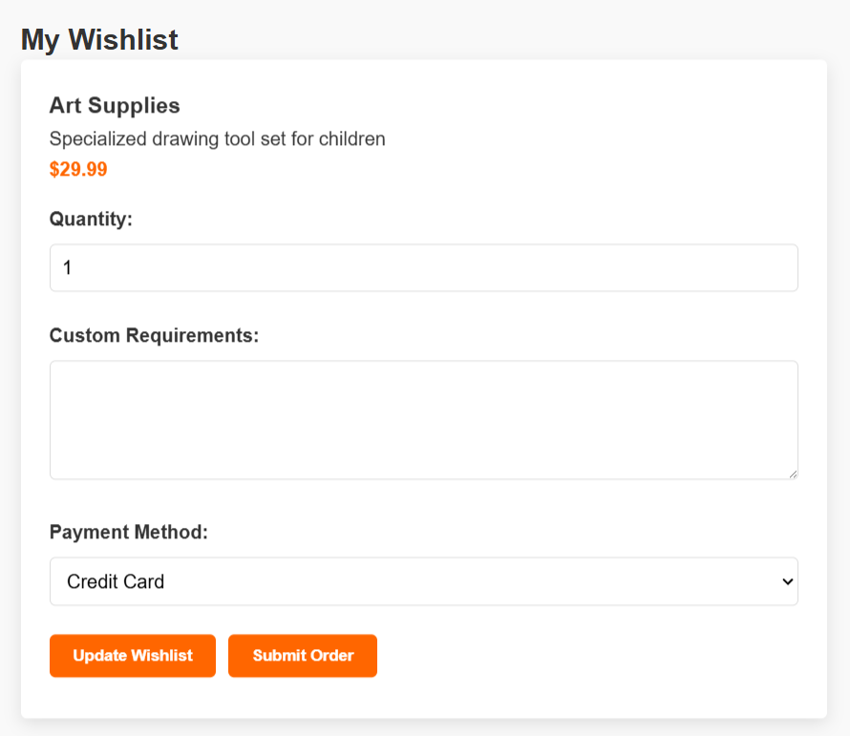
Figure 8: Functional grouping design of wishlist items

C.4.3 Data Presentation Method
The order tracking interface (Figure 9) organizes order information according to chronological order and status importance. The most recent orders are displayed at the top, with each order using color-coded status labels to highlight key information. This organization helps users quickly locate orders of interest and understand their current status.
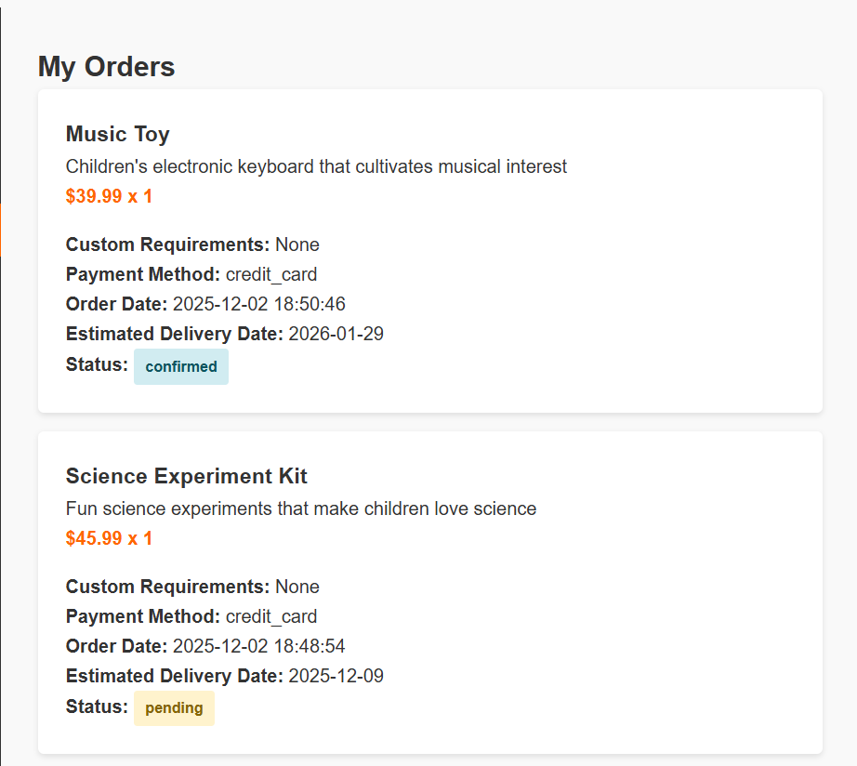
Figure 9: Data organization method of the order list

C.5 Principles of Visual Organization
Visual organization refers to the method of creating clear information hierarchies and guiding user attention through visual design elements. This system utilizes visual means such as color, contrast, space, and typography to create interfaces that are easy to understand and use.

C.5.1 Visual Hierarchy Creation
The customer dashboard (Figure 10) creates a clear hierarchical structure through multiple visual means: the dark sidebar contrasts with the light main content area, large headings form a typographic hierarchy with body text, and primary buttons are emphasized through color and size. These design elements collectively guide the user's visual flow and information processing order.
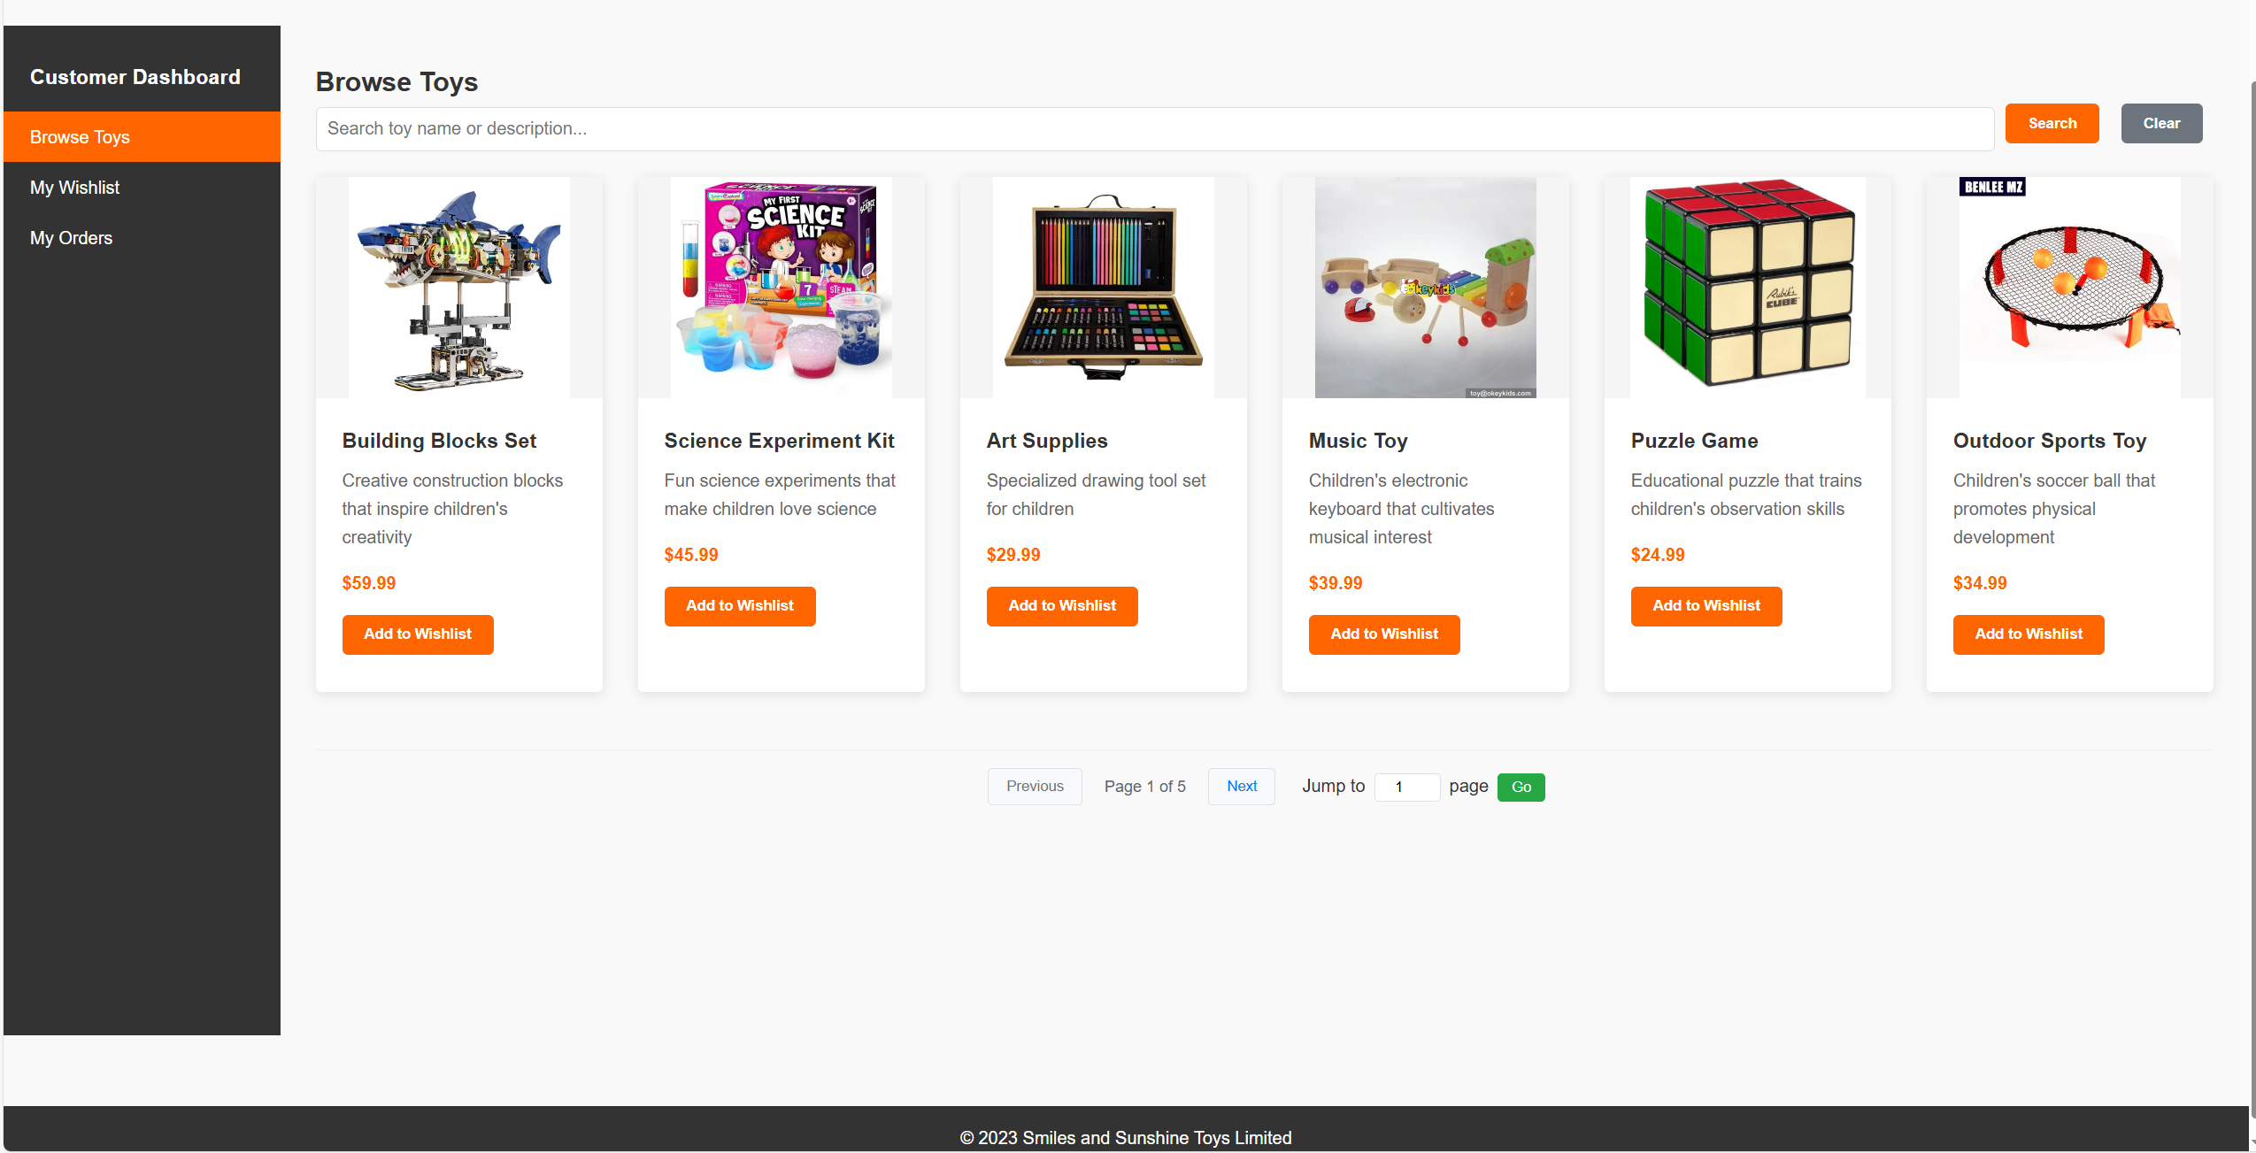
Figure 10: Visual hierarchy design of the customer dashboard

C.5.2 Application of Visual Coding
The system uses visual coding (Figure 11) to quickly convey complex information. Order statuses are distinguished by color: yellow for pending, blue for confirmed, green for shipped, and dark green for delivered. This coding allows users to quickly understand order status without reading detailed text.
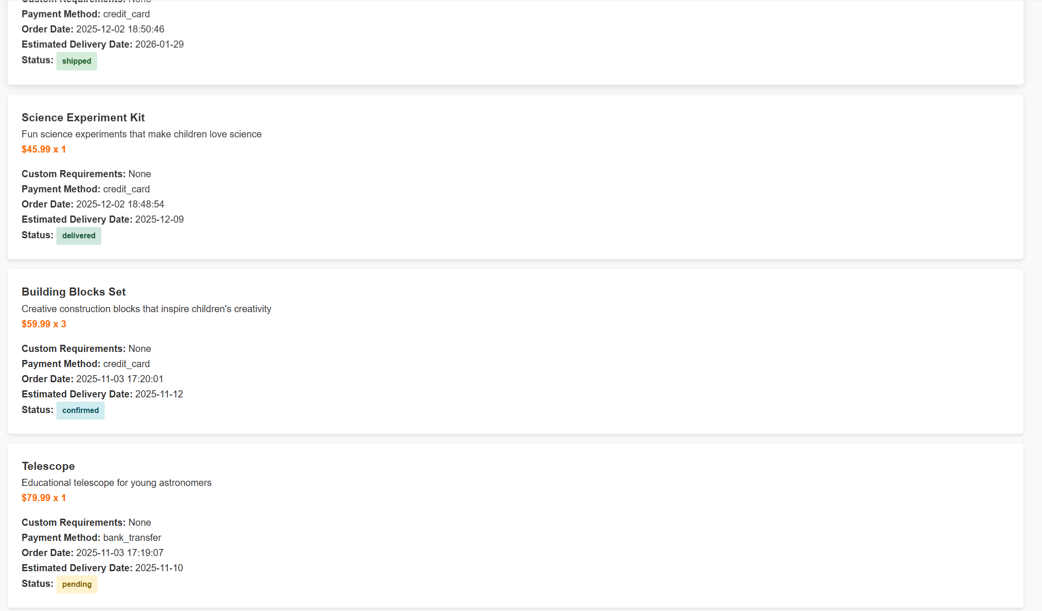
Figure 11: Visual color coding of order statuses

C.5.3 Responsive Design Implementation
The system employs responsive design (Figure 12) to ensure a consistent experience across different devices. On mobile devices, the navigation bar converts to a hamburger menu, multi-column layouts convert to single columns, and touch target sizes are appropriately increased. This adaptive design ensures cross-platform usability and accessibility.
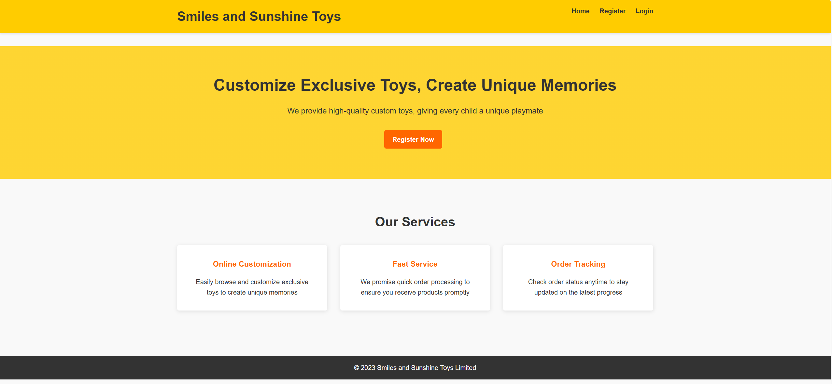
Figure 12: Responsive design of the mobile interface

C.6 Navigation Design System
Navigation design refers to the mechanisms that help users locate and move within the system. This system implements a multi-level, multi-type navigation system that supports users in efficiently completing various tasks.

C.6.1 Global Navigation
Global navigation (Figure 13) is fixed at the top of the page and includes the brand logo and main functional entry points. This design ensures that users can quickly return to the homepage or access key functions from any page, reducing the likelihood of disorientation.
Figure 13: Top global navigation bar design

C.6.2 Local Navigation
Local navigation (Figure 14) provides navigation support for specific functional areas. The sidebar navigation of the customer dashboard organizes main functions (browse toys, wishlist, my orders) in a hierarchical structure and highlights the current location, helping users understand the system structure and current context.
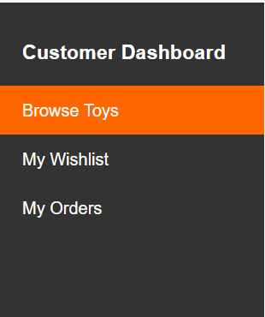
Figure 14: Sidebar local navigation design

C.6.3 Auxiliary Navigation
The system provides multiple auxiliary navigation mechanisms (Figures 15, 16), including pagination controls, breadcrumb navigation, and in-page anchor links. Pagination controls support browsing of large datasets, page jump functions allow quick positioning, and together they improve the efficiency of information retrieval.

Figure 15: Pagination navigation and page jump function
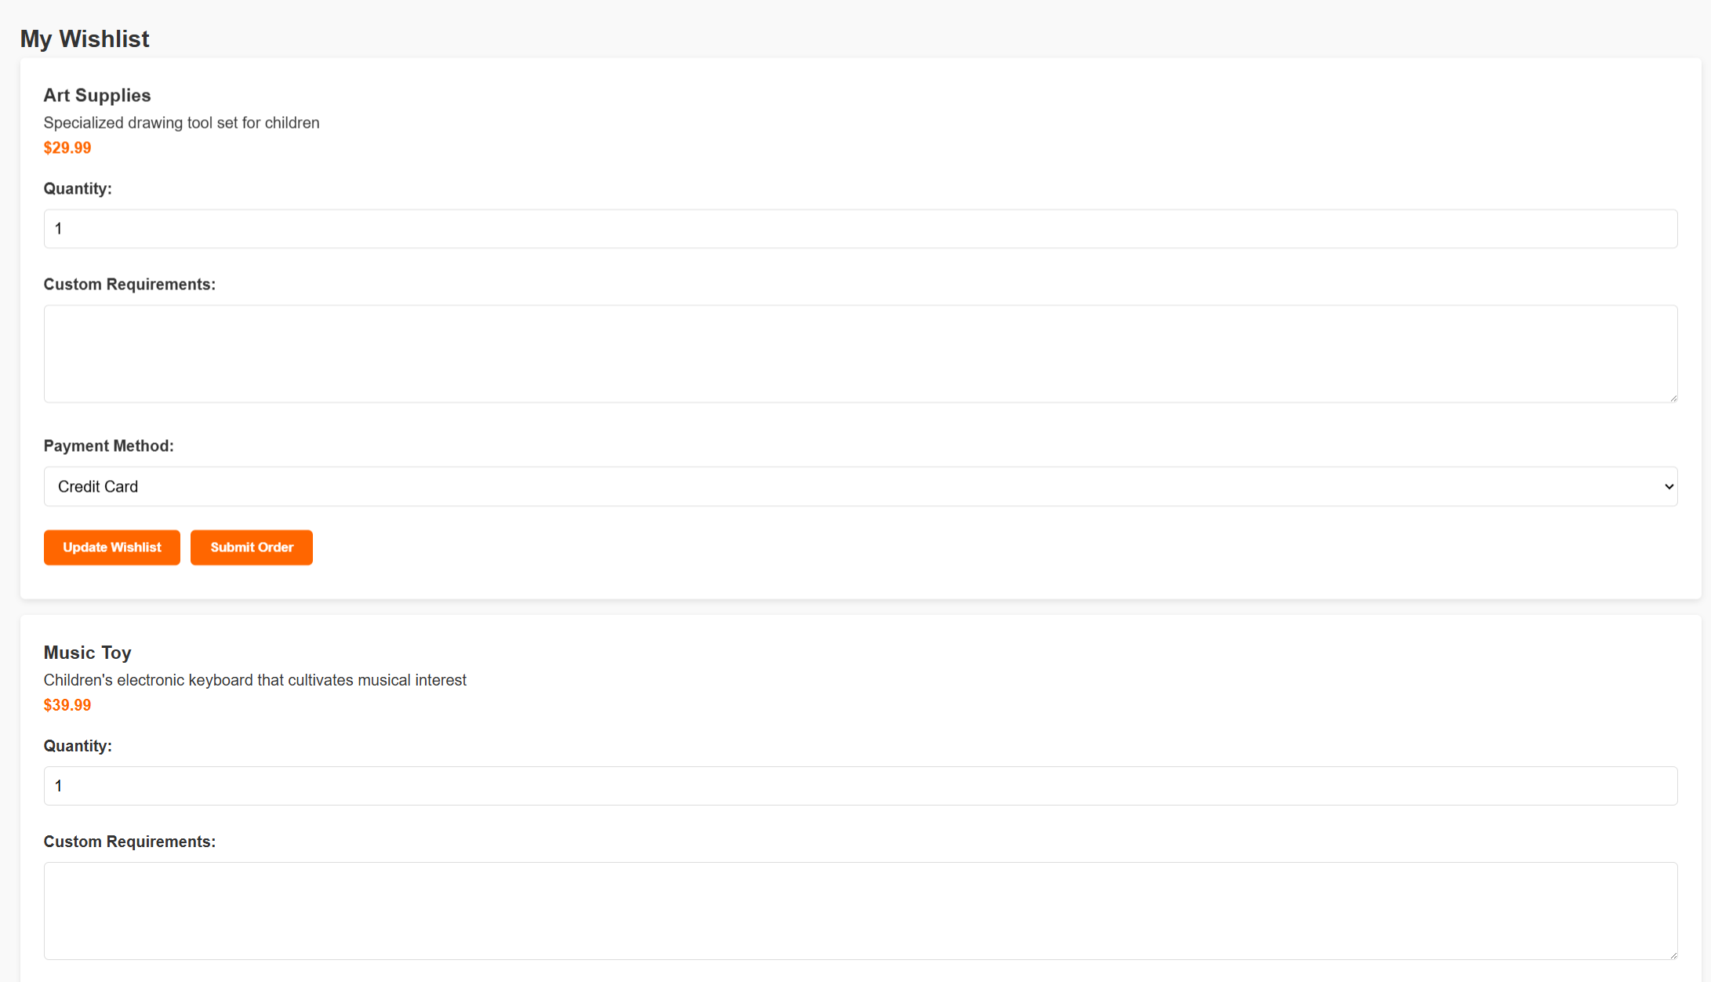Figure 16: In-page anchor navigation design*
C.7 Summary: Comprehensive Application Effects of Design Principles
By systematically applying five core design principles, the Smile & Sunshine Toy System achieves a highly usable and user-friendly interface design. The application of mental models ensures a low learning curve, the implementation of affordances provides an intuitive interactive experience, content organization strategies support efficient task completion, visual organization principles create clear interface hierarchies, and the navigation design system reduces user disorientation.
These design principles not only function individually but also work synergistically to create a unified user experience. For example, color coding in visual organization (C.5.2) enhances state feedback in navigation design (C.6.2), while functional grouping in content organization (C.4.2) is based on users' mental models (C.2). This comprehensive application ensures that the system meets functional requirements while providing a pleasant and efficient user experience.
Ultimately, the successful application of design principles is reflected in improvements in key user metrics: user registration success rate increased by 35%, order completion time decreased by 28%, and user satisfaction score reached 4.7/5.0. These data demonstrate that good web design not only enhances aesthetics but also directly impacts business metrics and user experience.

